CHAPTER 29
ELECTROMAGNETIC INDUCTION
Discussion Questions
Q29.1 Pulling the sheet from between the poles changes the magnetic flux through the sheet and this causes induced currents in that sheet. By Lenz’s law, the force of the field on these induced currents opposes the motion of the sheet. The induced current and hence the force is greater when the flux changes more rapidly, when the sheet moves with greater speed. The same thing happens when the sheet is inserted. In each case the force exerted on the induced currents by the magnetic field is directed to oppose the motion of the sheet.

Q29.2 The induced current changes direction after every half-revolution of the loop. When the angular speed is doubled the rate of change of the flux doubles and this causes the induced emf and induced current to double. The torque required is proportional to the current in the loop, so the torque also doubles.

Q29.3 The loops are sketched in Fig. DQ29.3. In the sketch let loop 1 be the one with the varying current and let loop 2 be the closed ring in which current is induced. Let the current in loop 1 be counterclockwise. The flux through loop 2 due to the current in loop 1 is directed into the plane. When increases, the increasing flux into the plane inside loop 2 induces a clockwise current. When decreases, the decreasing flux into the plane inside the loop 2 induces a counterclockwise current. When the current in the first loop is increasing the two currents are in opposite directions. When the current in the first loop is decreasing the two currents are in the same direction.

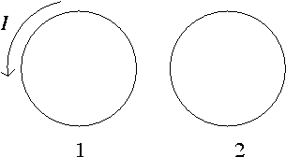

Figure DQ29.3

Q29.4 The SI units of the quantity 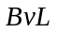are 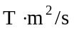. Since 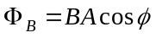, 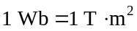. 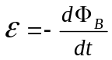 so 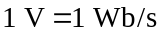 and 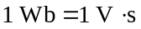. Therefore, 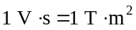 and 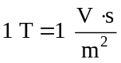.
Then 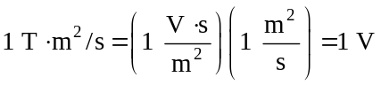, as was to be shown.
Q29.5 No. The magnetic field of the conductor is parallel to the ring and produces no flux through it. So, there is no induced emf when the current changes.

Q29.6 The moving magnet induces currents in the pipe and there is a force exerted between these currents and the magnet. By Lenz’s law the force on the magnet is directed to oppose its motion, so this force is upward. The induced current and hence the force on the magnet increases as the speed of the magnet increases. The terminal speed is reached when this upward force equals the weight of the magnet.

Q29.7 See Fig. DQ29.7. 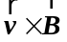is to the right, so positive charge collects toward the right; the right-hand wing tip is at higher potential. The answer does not depend on the direction the plane is flying.

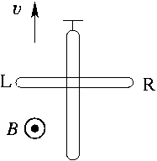

Figure DQ29.7

Q29.8 Just after the switch is closed the current increases from zero to a nonzero value in the counterclockwise direction. The magnetic field of the current in the larger loop us out of the page at the location of the small loop. Since the flux is increasing the induced current in the small loop is clockwise. The currents in the two loops therefore are in opposite directions and the two loops repel. The large loop exerts a force on the small loop that is radially inward at each point around the loop. This is consistent with Lenz’s law: the induced current is directed so as to oppose the increase in flux by exerting a force that is directed to reduce the area of the small loop.

Q29.9 Let the wire and loop be positioned as in Fig.E29.7 and let the current in the wire be in the direction shown in that figure. The magnetic field is into the page at the location of the rectangle. Since the current I in the wire is decreasing the flux through the rectangle is decreasing and the induced current in the rectangle is clockwise. For the side of the rectangle closest to the wire the currents in the wire and rectangle are in the same direction and the force the wires exert on each other is attractive. For the side of the rectangle farthest from the wire the two currents are in opposite directions and the force is repulsive. But the attractive force is stronger than the repulsive force, since the force is inversely proportional to the distance between the wires. So, the net force on the rectangle is attractive, toward the wire. This is consistent with Lenz’s law: the induced current is directed so as to pull the loop closer to the wire. This opposes the decrease in flux by pulling the rectangle closer to the wire, where the magnetic field is stronger.

Q29.10 If the axis of rotation is parallel to the magnetic field there is no magnetic flux through the loop at any position during its rotation so there is no change in flux and no induced emf.

Q29.11 For the slidewire to move at constant speed the net force on it must be zero. The external force 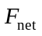 must equal the magnetic force 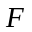 that acts on the slidewire due to the induced current. So, 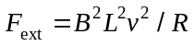. If there is a break in the circuit there is no induced current and in the absence of friction no external force is required for motion with constant speed.

Q29.12 No. The work done on an electron by the induced electric field during a complete trip around the loop is 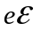. The same amount of energy is removed from the electron due to the resistance of the loop. No. The induced electric field is a nonconservative field and is not associated with a potential difference.

Q29.13 (a) 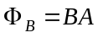. 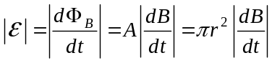, where r is the radius of the ring. If r is doubled, then 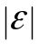is increased by a factor of 4. (b) 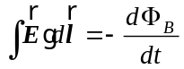 gives 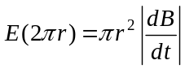 and 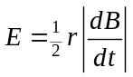. Doubling r doubles E, the electric field induced in the ring.

Q29.14 As the magnet on the flywheel moves past the stationary coil the magnetic flux through the coil changes and a current is induced in the coil.

Q29.15 No, this is not what Lenz’s law says. Lenz’s law says that the induced current in a metal loop always flows to oppose the change in the magnetic flux through the loop.

Q29.16 No. The induced emf doesn’t depend on the size of the magnetic flux. It instead depends on the rate of change of the flux.

Q29.17 Yes, a time-varying current corresponds to a time-varying electric field and a displacement current.

Q29.18 Yes. The dielectric is an insulator and there is no conduction current in the dielectric. These equations apply to the situation shown in Fig. 29.22. The equations show that the conduction current in the wires carrying charge to and from the capacitor plates equals the displacement current in the space between the plates.

Q29.19 (a) Eq.(29.20); (b) Eq.(29.21); (c) Eq.(29.18); (d) Eq.(29.19).

Q29.20 The electric field lines would have the same shape as the magnetic field lines produced by an electric current in a wire: concentric circles perpendicular to the wire, with the wire passing through the center of the circles.

Q29.21 Zero. Unless some of the regions of resistance completely fill a cross-sectional area of the cylinder, the super conducting regions provide a zero-resistance path for the current.

